POSTER PRESENTATION



Roadmap for Design and Implementation

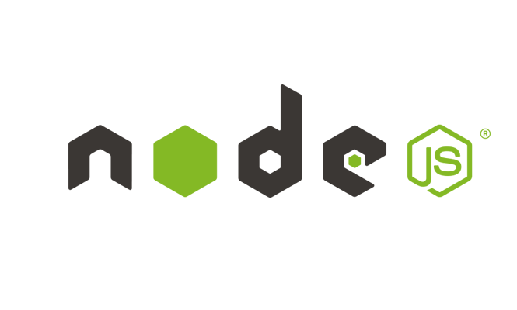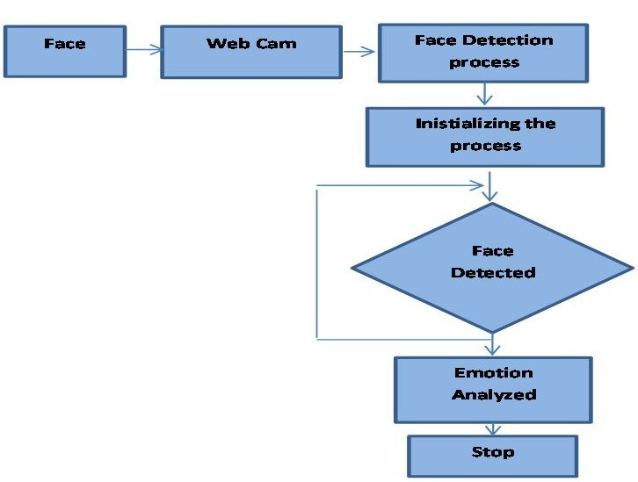

**Despite the growing focus on nutrition, individuals in India often face challenges finding accurate nutritional information for local, everyday foods. Existing resources mainly cater to global or packaged foods, leaving a gap in guidance for traditional Indian dishes. NutriTell bridges this gap by providing detailed nutritional content for common Indian foods, empowering users to make health-conscious choices based on accurate, locally relevant data.**

Department: Computer Science & Engineering

G.L. Bajaj Institute of Technology and Management, Gr. Noida

Group ID:2CSE_F2G9: NutriTell: Nutrition Tracker

Problem Statement:

Motivation:

**Empowering Nutritional Awareness**: Enhancing users' understanding of their dietary choices by providing accurate nutritional information tailored to local foods

**Team Members**:

* VISHANT KUMAR RAI

(2301920100360)

**Supporting Healthy Lifestyles**: Facilitating users' health goals by offering tools to track and analyze their nutrient intake, encouraging consistency and accountability.

* YASHDEEP

(2301920100370)

**Fostering Community Engagement**: Creating a supportive environment where users can share their experiences and successes, motivating each other towards better health.

Mentor

**MENTOR:**

Ms. Anju Joshi

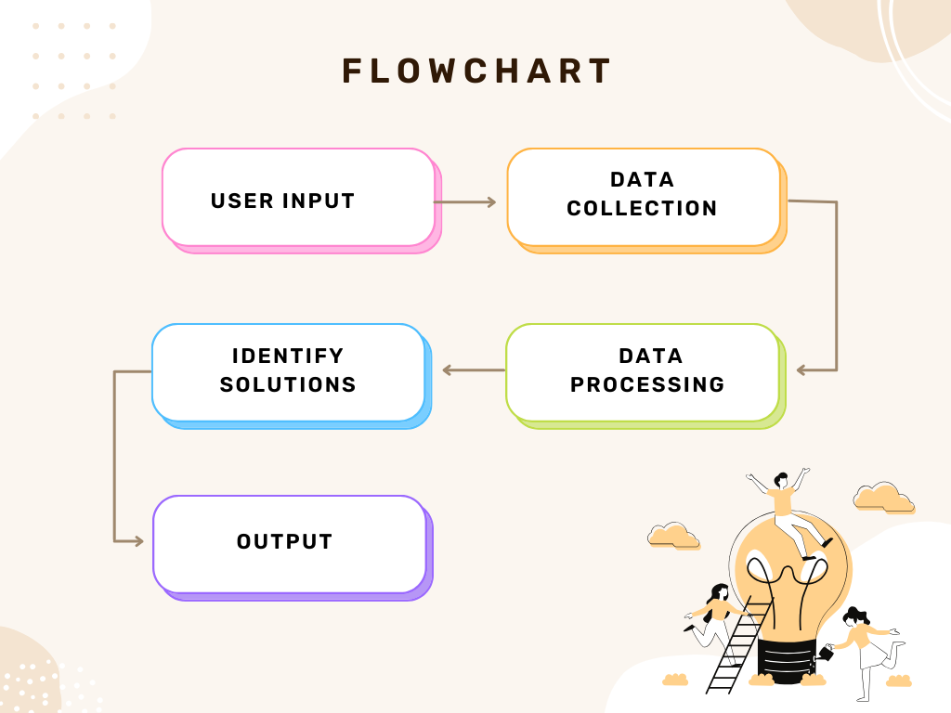

Provide accurate nutritional information for **commonly consumed Indian foods**.

Objectives:

Proposed Idea/Solution:

Technologies Used:

Facilitate **easy logging** of meals and ingredients to help users monitor their nutrition effortlessly.

Allow users to **track their daily nutrient intake** based on these local foods.



Enable users to log meals and **monitor their daily nutrient** consumption.

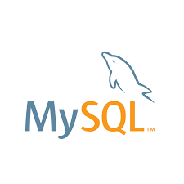

Impacts and benefits

Sustainability Goals

Solution Environment

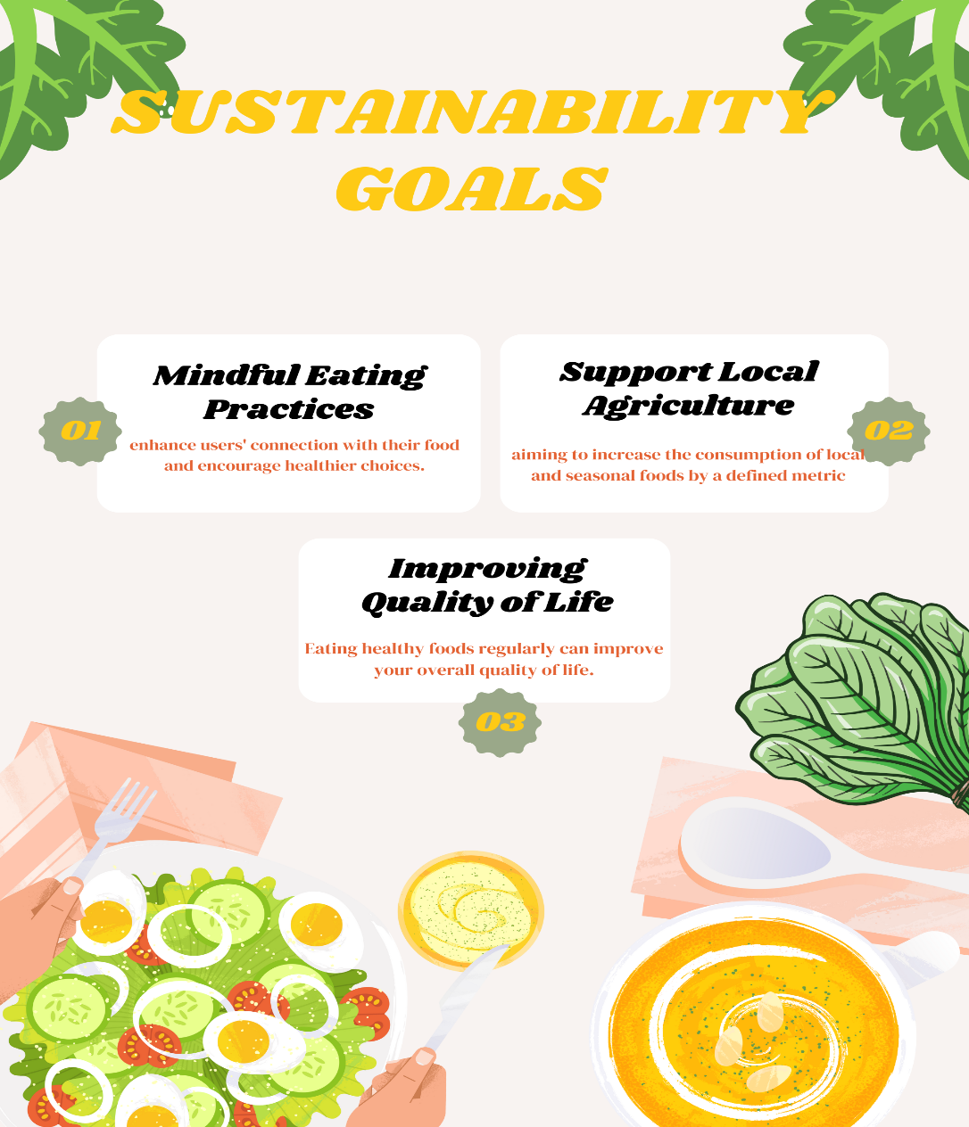

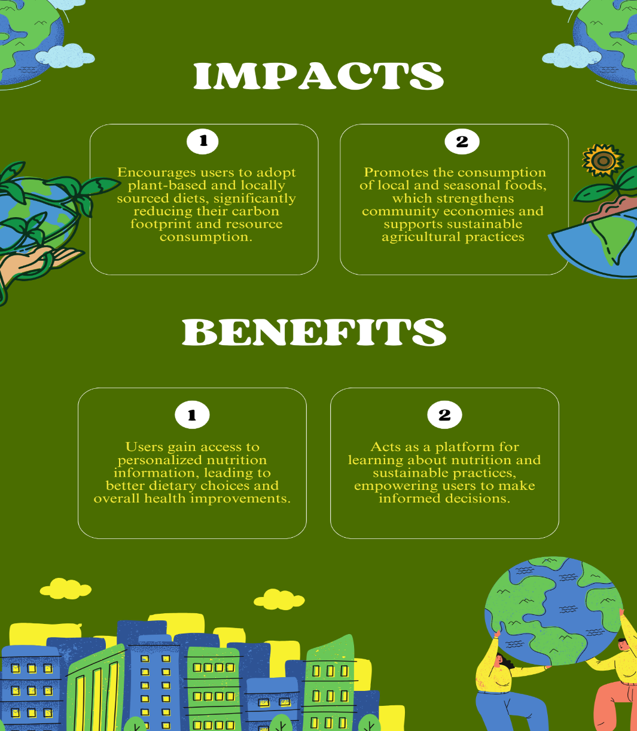

**Promoting Plant-Based Diets**: NutriTell can encourage users to choose plant-based foods, which have a lower environmental impact, by highlighting their nutritional benefits and providing recipes.

**Waste Reduction Tips**: The app can educate users on minimizing food waste with meal planning tools and recipes that use leftovers, promoting efficient resource use and reducing environmental harm.

**Local and Seasonal Food Suggestions**: NutriTell can recommend locally sourced and seasonal foods, reducing the carbon footprint associated with food transportation and encouraging sustainable sourcing practices.

# Roadmap for Design and Implementation



.